Assignment – 15

Using Subqueries with DML Commands.

1. Assume there is a table called Multicust, with all of the same column definitions as Salespeople. Write a command that inserts all salespeople with more than one customer into this table.
2. 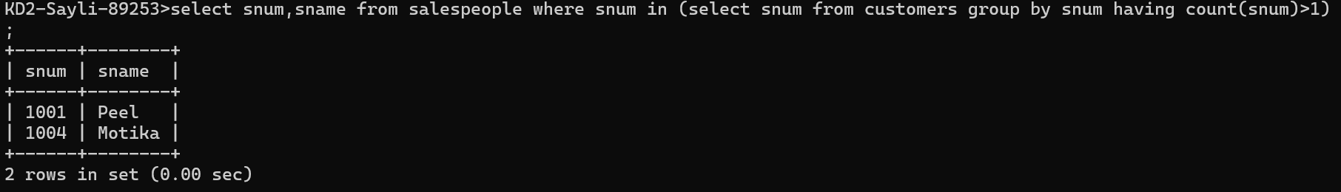
3. Write a command that deletes all customers with no current orders.



1. Write a command that increases by twenty percent the commissions of all salespeople wih total orders above Rs. 3,000.

